Supply Chain Digitization
Week 6 | Session 3: Predictive Maintenance — Classification Tree Case Study
Session Agenda
- Case study context — manufacturing plant, machine breakdowns, plant manager
- Data collected — 7 input features + 1 target variable (1000 instances)
- Model chosen — Classification tree (decision tree) and why
- Decision tree output — 4 leaf nodes with rules, probabilities, and support
- Business rules derived — how shop floor workers use the model
- Two worked predictions (Machine 1 and Machine 2)
- Next session: how to BUILD the classification tree from scratch (Python hands-on)
Case Study Context — The Problem
- Setting: Manufacturing plant with intermittent production stoppages over the last few months
- Problem: Machines breaking down 1–2 times per month → production halts → customers not getting products on time → customer churn risk
- Stakeholder: New plant manager (data science trained) appointed to solve this
- Goal: Develop a predictive model to forecast WHICH machine will fail BEFORE it actually breaks down → take proactive corrective action → eliminate production stoppages
- Analytics type used: Predictive analytics (classification model) → also feeds into Prescriptive (schedule maintenance before failure)
- Model chosen: Classification tree (subset of Decision Tree) — chosen because it is interpretable by shop floor workers, not just data scientists
★ The goal is NOT to understand why machines fail (diagnostic). It is to predict WHICH machine will fail next (predictive) → so corrective action can be taken (prescriptive). This is "Predictive Maintenance."
Data Collected — 1000 Instances, 7 Features + 1 Target
- Dataset size: 1000 historical instances — each representing one machine over one observation period
- Data includes BOTH failure and non-failure instances: Critical — model must learn to distinguish between the two. Having only failure data would bias the model.

Table 1: Features collected and what they represent — inputs to the classification model
Feature (Input Variable) | Unit / Scale | What It Represents
Age of machine | Years | How long the machine has been in operation. Older machines → higher failure risk.
Utilization | % (0–100) | Percentage of time the machine is being used. Higher utilization → more wear → higher failure risk.
MTBF (Mean Time Between Failures) | Hours/days | Average time between two successive failures. Higher MTBF → machine failing less frequently → lower current risk.
Unplanned Downtime | % | Percentage of time machine was down unexpectedly (not scheduled maintenance). Higher = more historical failure incidents.
Oil Contamination (NAS value) | NAS scale | Cleanliness of machine oil. Higher contamination = dirty oil = higher risk of mechanical failure.
Overhauling Schedule Compliance | % (0–100) | How consistently planned overhauls are carried out. 95.6% = overhaul missed only 4.4% of scheduled times. Lower % = more missed overhauls = higher failure risk.
Schedule Lubrication Compliance | % (0–100) | How consistently scheduled lubrication is carried out. Lower = more missed lubrication = higher friction = higher failure risk.
Machine Failure? (Target variable) | Binary: 1/0 (Yes/No) | Whether the machine actually failed (1) or did not fail (0) in that instance. This is what the model must PREDICT.
Data structure (sample data):
Sr. No | Age | Utilization | MTBF | Unplanned Downtime | Oil Contamination (NAS) | Overhauling Schedule Compliance | Schedule Lubrication Compliance | Machine Failure (1 means failed)
0 | 14 | 89.8 | 8.7 | 2.38 | 7 | 95.6 | 95.8 | 1
1 | 15 | 90.9 | 24.2 | 1.71 | 5 | 99.1 | 90.5 | 0
2 | 5 | 94.6 | 8.2 | 1.23 | 6 | 77.8 | 91 | 1
3 | 3 | 92.1 | 8.4 | 2.57 | 10 | 96 | 81.9 | 1
4 | 13 | 81.6 | 24.4 | 4.3 | 9 | 91.6 | 83.8 | 0
... | ... | ... | ... | ... | ... | ... | ... | …
995 | 12 | 75.2 | 19.5 | 0.57 | 12 | 97 | 99.9 | 1
996 | 14 | 85.8 | 25 | 3.73 | 10 | 96.8 | 81.1 | 0
997 | 10 | 89.6 | 8.3 | 4.85 | 9 | 96.5 | 78 | 1
998 | 6 | 75.7 | 19.7 | 2.14 | 7 | 87.3 | 84.8 | 1
999 | 14 | 77.7 | 8.3 | 1.46 | 13 | 83.2 | 81.5 | 0
Predict | 11 | 78 | 15 | 3 | 8 | 92 | 90 | ???
Why Classification Tree (Decision Tree)?
- Problem type: Binary classification — machine will FAIL (1) or will NOT FAIL (0)
- Key requirement: Model must be interpretable by shop floor workers (not just data scientists) → decision tree provides clear IF-THEN rules
- Alternative models: Logistic regression, neural networks, random forest — accurate but harder to explain to non-technical staff
- Decision tree advantage: Visual, rule-based structure → workers can follow a simple flowchart → no data science background needed to use the output
- Output: Prediction (fail/not fail) + probability of failure + support for that probability
★ Exam tip: Classification tree is preferred for predictive maintenance because it balances accuracy with interpretability. Always mention WHY a model was chosen — interpretability for shop floor use is the key reason here.
Decision Tree Output — 4 Leaf Nodes (Business Rules)
- Key insight: Out of 7 input features, the model uses only 3 for prediction: Oil Contamination | MTBF | Utilisation
- Root split (Node 0): First split is on Oil Contamination at threshold 5.5
  - Oil Contamination > 5.5 → go right (Node 2) → then check MTBF
  - Oil Contamination ≤ 5.5 → go left (Node 1) → then check Utilisation
- Leaf nodes (4 terminal nodes — 3, 4, 5, 6): Each gives a prediction + probability + support

Table 2: Decision tree leaf nodes — business rules for shop floor use
Node | Condition 1 (Oil Contamination) | Condition 2 (Utilisation or MTBF) | Prediction | Classification Accuracy (Prob.) | Support
3 | Oil ≤ 5.5 | Utilisation ≤ 92.05% | Will NOT fail ✓ | 83% | 16%
4 | Oil ≤ 5.5 | Utilisation > 92.05% | Will FAIL ✗ | 88% | 5%
5 | Oil > 5.5 | MTBF ≤ 23.95 | Will FAIL ✗ | 77% | 70%
6 | Oil > 5.5 | MTBF > 23.95 | Will NOT fail ✓ | 71% | 9%
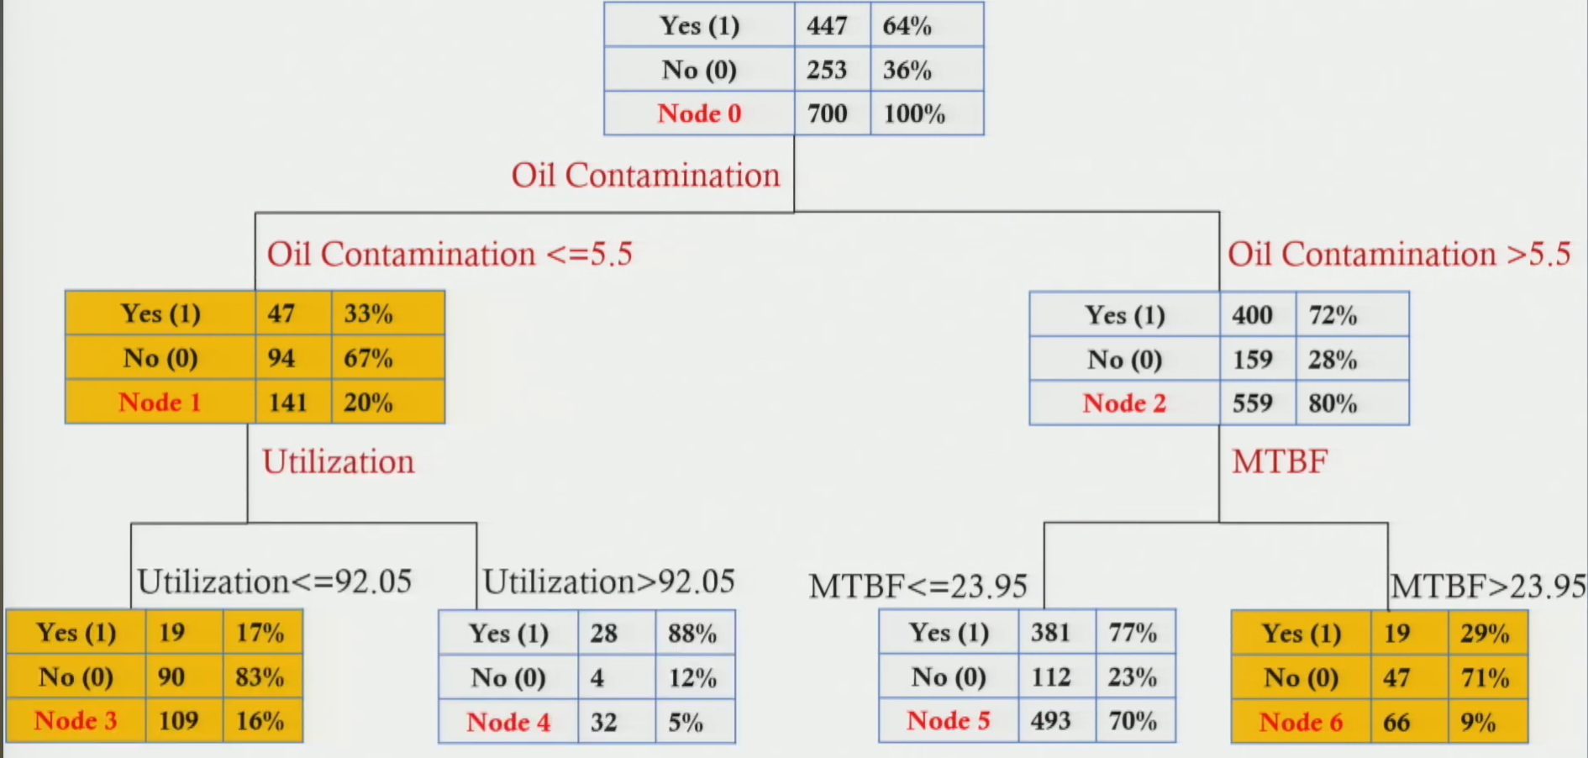
Understanding the Output — Three Key Terms
- Prediction: "Will FAIL" or "Will NOT FAIL" — the model's classification for that combination of parameter values
- Accuracy / Probability: What % of instances with this rule combination actually had that outcome in historical data. E.g. 77% means 77 out of 100 machines with Oil > 5.5 and MTBF ≤ 23.95 actually failed.
- Support: What % of the total 1000 instances fall into this node. 70% support = 700 of 1000 training instances land in Node 5. High support = rule is based on more data = more confidence in the rule.
★ High accuracy + high support = most reliable prediction. Node 5 (77% accuracy, 70% support) is the most impactful rule — it covers 70% of all instances and predicts failure with 77% probability.
Shop Floor Business Rules — How Workers Use the Model
- Print the 4 business rules and post them in the shop floor. Workers only need to monitor 3 parameters:
  - Oil Contamination (NAS value — check against threshold 5.5)
  - MTBF (Mean Time Between Failures — check against threshold 23.95)
  - Utilisation (% — check against threshold 92.05%)

- Step 1: Check Oil Contamination. Is it ≤ 5.5 or > 5.5?
  - If > 5.5 → check MTBF → follow Node 5 or Node 6 rule
  - If ≤ 5.5 → check Utilisation → follow Node 3 or Node 4 rule
- Step 2: Check the second parameter (MTBF or Utilisation) → arrive at one of 4 leaf nodes
- Step 3: Read the prediction + probability → if machine predicted to fail → alert manager → schedule preventive maintenance immediately
★ Simplicity is the design goal. 3 parameters, 4 rules, printed on a sheet. Any worker can predict machine failure without knowing anything about machine learning.
Two Worked Predictions — Apply the Model
Table 3: Step-by-step application of the decision tree to two specific machines
Parameter | Machine 1 (Example from class) | Machine 2 (Example from class)
Age | 11 years | 4 years
Utilisation | 78% | 91%
MTBF | 15 | 24
Unplanned Downtime | 3% | 4%
Oil Contamination | 8 (> 5.5) | 5 (≤ 5.5)
Overhauling Compliance | 92% | 88%
Lubrication Compliance | 90% | 87%
Step 1: Check Oil Contamination | 8 > 5.5 → go to Node 2 branch (Oil > 5.5 side) | 5 ≤ 5.5 → go to Node 1 branch (Oil ≤ 5.5 side)
Step 2: Check 2nd parameter | MTBF = 15 ≤ 23.95 → Node 5 | Utilisation = 91% ≤ 92.05% → Node 3
Prediction | WILL FAIL ✗ | Will NOT Fail ✓
Accuracy / Probability | 77% | 83%
Support | 70% | 16%
Machine 1 — Walkthrough
- Oil Contamination = 8 → 8 > 5.5 → follow right branch (Node 2)
- MTBF = 15 → 15 ≤ 23.95 → Node 5
- Prediction: Machine WILL FAIL | Probability = 77% | Support = 70%
- Action: Alert maintenance team immediately. Schedule inspection and servicing before failure occurs.
Machine 2 — Walkthrough
- Oil Contamination = 5 → 5 ≤ 5.5 → follow left branch (Node 1)
- Utilisation = 91% → 91% ≤ 92.05% → Node 3
- Prediction: Machine will NOT FAIL | Probability = 83% | Support = 16%
- Action: No immediate maintenance needed. Continue normal operations. Monitor oil contamination closely (borderline at 5, close to threshold 5.5).
★ Exam tip: For any exam question on this model — always show the step-by-step path through the tree. State (1) which parameter is checked first, (2) which node you land in, (3) the prediction, probability, and support. Do this for both machines if asked.
Interpreting Support — Why It Matters
- Node 5: 70% support = 700 of 1000 training instances fall here. This is the most data-rich node → prediction is most reliable.
- Node 4: 5% support = only 50 of 1000 instances. High accuracy (88%) but based on very few data points → use with caution.
- Node 6: 9% support = 90 instances. Reasonable but not as strong as Node 5.
- Node 3: 16% support = 160 instances. Moderate support — reasonably reliable for not-fail prediction.
- Rule of thumb: High support + high accuracy = most actionable rule. Low support even with high accuracy = treat the prediction cautiously.
Feature Selection — Why Only 3 of 7 Parameters?
- Model was given all 7 parameters but the decision tree found that only 3 were needed to make accurate predictions:
  - Oil Contamination — most discriminatory variable (used at root split)
  - MTBF — second split on the high-contamination branch
  - Utilisation — second split on the low-contamination branch
- Age, unplanned downtime, overhauling compliance, lubrication compliance: Not selected by the model — either redundant (correlated with the 3 selected) or less discriminatory
- Benefit: Fewer parameters to monitor → simpler for shop floor staff → lower data collection burden → faster decision making
★ Decision trees automatically perform feature selection — they only split on variables that improve predictive accuracy. This makes them practically useful in addition to statistically sound.
Analytics Chain in This Case Study
Analytics Type | How It Was Applied
Descriptive | Past machine data collected for 1000 instances across 7 parameters. Historical failure rate identified. Which machines failed most often? How often? When?
Diagnostic | Which parameters are associated with failure? Oil contamination, MTBF, and utilisation found to be most discriminatory — these explain WHY machines fail.
Predictive | Classification tree trained on 1000 instances → model predicts whether a machine WILL fail given current parameter values. Output: fail/not-fail + probability + support.
Prescriptive | When model predicts failure with high probability → prescribe action: schedule preventive maintenance, order replacement parts, adjust oil system, reduce machine utilisation. Goal: prevent the failure from occurring.

Session Summary
- Problem: Manufacturing plant with 1–2 machine breakdowns per month → production halts → customer dissatisfaction
- Approach: Predictive maintenance using classification tree model
- Data: 1000 instances | 7 features (age, utilisation, MTBF, unplanned downtime, oil contamination, overhauling compliance, lubrication compliance) + 1 target (failed / not failed)
- Model: Classification tree — interpretable, rule-based, usable by non-technical shop floor workers
- 3 parameters selected by model: Oil Contamination | MTBF | Utilisation (out of 7 input features)
- 4 business rules (leaf nodes): Node 3 (not fail, 83%, 16%) | Node 4 (fail, 88%, 5%) | Node 5 (fail, 77%, 70%) | Node 6 (not fail, 71%, 9%)
- Machine 1 prediction: Oil = 8 > 5.5, MTBF = 15 ≤ 23.95 → Node 5 → WILL FAIL (77% probability)
- Machine 2 prediction: Oil = 5 ≤ 5.5, Utilisation = 91% ≤ 92.05% → Node 3 → Will NOT FAIL (83% probability)
- Next session: Build this classification tree from scratch — theory + Python hands-on coding

